 | Instruction to your  Bank or Building Society  to pay by Direct Debit | 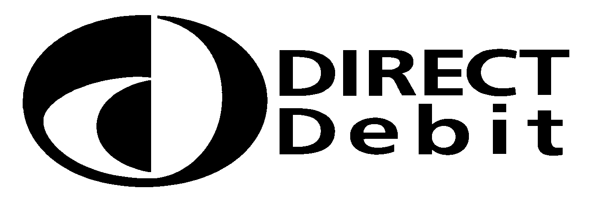

Please fill in the whole form and send it to:
The Secretary
Countrystyle Recycling Ltd.
Ashford Road
Lenham
Maidstone
Kent ME17 2DL

Originator’s Identification Number

6
0
7
8
8
8
Name(s) of Account Holder(s)

Reference Number

Bank/Building Society account number
Instruction to your Bank or Building Society

Please pay Countrystyle Recycling Ltd Direct Debits from the account detailed in this Instruction subject to safeguards Branch Sort Code assured by the Direct Debit Guarantee. I understand that this
instruction may remain with Countrystyle Recycling Ltd and, if so,

details will be passed electronically to my Bank/Building Society.

Name and full postal address of your Bank or Building
Society
Signature(s)

Date

To: The Manager Bank/Building Society

Address

Postcode

Banks and Building Societies may not accept Direct Debit Instructions for some types of account.

This guarantee should be detached and retained by the Payer
The Direct Debit Guarantee
This Guarantee is offered by all Banks and Building Societies that accept instructions to pay Direct Debits.
If there are any changes to the amount, date or frequency of your Direct Debit, Countrysytyle Recycling Ltd will notify you 10 working days in advance of your account being debited or as otherwise agreed. If you request Countrystyle Recycling Ltd to collect a payment, confirmation of the amount and date will be given to you at the time of the request.
If an error is made in the payment of your Direct Debit by Countrystyle Recycling Ltd or your Bank or Building Society, you are entitled to a full and immediate refund of the amount paid from your bank or building society.
If you receive a refund you are not entitled to, you must pay it back when Countrystyle Recycling Ltd asks you to.
You can cancel a Direct Debit at any time by simply contacting your Bank or Building Society. Written confirmation may be required. Please also notify us.

